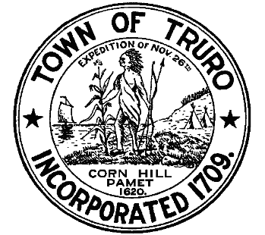
TOWN OF TRURO
24 Town Hall Road
P.O. Box 2030, Truro, MA 02666
Tel: 508-349-7030 Ext. 140 or 124
Fax: 508-349-5505

PRESS RELEASE
Longnook Beach Access Alternative 5 Moving to Final Design

FOR IMMEDIATE RELEASE: February 3, 2025 – In April 2024 Town of Truro public officials closed the access area to Longnook Beach for emergency reasons due to a dangerously steep and eroding coastal bank. Town of Truro public officials contracted with the Center for Coastal Studies and the Woods Hole Group to look at safer alternatives to access Longnook Beach from the parking lot. At the November 19, 2024 Select Board meeting, at approximately one hour, Jarrod Cabral, DPW Director and Mitch Buck, Senior Coastal Engineer and Project Manager at the Woods Hole Group discussed the evaluation of Longnook Beach access alternatives, of which there were five. The goal of the evaluation was to identify safer beach access that is more permanent, low impact, accessible, and easy-to-maintain. The Woods Hole Group recommended Alternative 5, which is explained below.

Alternative 5 – Description
Alternative 5 offers a straight path to the beach and minimizes loss of parking. The alternative requires establishing the pathway across Cape Cod National Seashore (CCNS) property, necessitating a Special Permit. This option utilizes an already existing path mapped by the Woods Hole Group. This gentler path extends farther along the face of the coastal bluff. To make it more accessible, the extra length would extend onto CCNS property. Through the evaluation process, the Woods Hole Group identified that there is existing hardscape and a shed on CCNS property that will require removal and relocation to the town-owned parcel.

Alternative 5 – Next Steps
The Town of Truro completed a site visit with the National Park Service (NPS) on Tuesday, January 14, 2025 and provided an update to the Select Board at their January 14, 2025 meeting, at approximately 52 minutes. The Town of Truro also met with the Federal Aviation Administration (FAA) on Thursday, January 16, 2025 to discuss ownership, as NPS owns the top portion of the dune and the FAA owns the bottom portion of the dune. The Town of Truro will advance Alternative 5 to a final design in support of a Special Permit to be submitted to NPS with a detailed narrative Scope of Work that indicates that the town is only to remove, regrade, and alter already disturbed land. The project will be reviewed on March 3 at the Conservation Commission Meeting. The goal is to conduct the work in March 2025 and reopen access for the 2025 beach season.
